

NAME: SUVETHA C
REGISTER NUMBER: 192421088

CASE STUDY ANALYSIS REPORT

INTELLIGENT SMART PRISON MONITORING AND INMATE MANAGEMENT PLATFORM

1. INTRODUCTION
Correctional facilities are essential institutions responsible for maintaining law and order in society by securely housing individuals who have violated legal regulations. Along with ensuring safety, these facilities are also responsible for rehabilitation, monitoring, and maintaining discipline among inmates. However, traditional prison systems face numerous operational challenges due to outdated practices and lack of technological integration.
Most prisons still depend on manual processes such as physical headcounts, handwritten records, and basic surveillance systems. These methods are not only time-consuming but also prone to human error. As prison populations grow and security threats become more complex, there is an urgent need to adopt advanced technologies.
The Intelligent Smart Prison Monitoring and Inmate Management Platform aims to address these issues by integrating modern technologies such as Artificial Intelligence (AI), Internet of Things (IoT), and cloud computing. This system provides real-time monitoring, predictive analytics, and automation to improve overall prison management.

2. UNDERSTANDING THE PROBLEM STATEMENT
2.1 Explanation in Own Words
The current prison system lacks real-time monitoring and efficient management tools. Officers often struggle to track inmate movements, manage visitor logs, and respond to emergencies quickly. The absence of intelligent systems leads to security risks such as escapes, violence, and unauthorized access.
The proposed system aims to develop a smart, automated, and intelligent platform that continuously monitors all activities within a prison. By using AI and IoT devices, the system can detect suspicious activities, predict risks, and notify authorities instantly.

2.2 Objectives of the Proposed System
Primary Objectives
- Continuous monitoring of inmates and staff
- Real-time detection of abnormal behavior
- Prevention of unauthorized access
- Improvement in emergency response
Secondary Objectives
- Automation of administrative tasks
- Improved record management
- Enhanced decision-making using data analytics
- Centralized monitoring system

2.3 Scope of the Problem
In Scope
- Inmate tracking using RFID
- AI-based video surveillance
- Visitor management system
- Emergency alert system
- Data storage and analytics
Out of Scope
- Judicial processes
- Court decision-making
- External policing systems

3. STAKEHOLDER ANALYSIS
3.1 Key Stakeholders
- Prison Administrators
- Correctional Officers
- Inmates
- Visitors
- Government Authorities
- IT Administrators

3.2 Roles and Responsibilities
Prison Administrators
They are responsible for overseeing prison operations, monitoring reports, and making strategic decisions.
Correctional Officers
They ensure discipline, monitor inmates, and respond to alerts generated by the system.
Inmates
They are monitored continuously and must follow institutional rules.
Visitors
They must follow strict security protocols and are monitored during visits.
Government Authorities
They ensure that prisons follow legal standards and human rights regulations.
IT Administrators
They manage the technical system, ensure data security, and maintain system performance.

3.3 Challenges Faced by Stakeholders
- Difficulty in tracking inmates manually
- High workload on officers
- Delayed emergency response
- Lack of real-time data
- Security threats and risks

4. CURRENT SYSTEM ANALYSIS
4.1 Existing System
The current system relies on:
- Manual attendance tracking
- CCTV cameras without AI
- Paper-based records
- Manual visitor registration

4.2 Strengths of Existing System
- Simple implementation
- Low initial cost
- Minimal technical dependency

4.3 Limitations
- No real-time monitoring
- High chance of human error
- Time-consuming processes
- No predictive capabilities
- Reactive security approach

4.4 Identified Gaps
- Lack of automation
- No centralized control
- Inefficient communication
- Limited data usage

5. PROPOSED SOFTWARE SOLUTION
5.1 Overview
The proposed system is an integrated platform that combines multiple technologies to create a smart and efficient prison management system.

5.2 System Components
- IoT Sensors
- RFID Tags
- Biometric Devices
- AI Cameras
- Cloud Servers

5.3 Functional Modules
1. Inmate Tracking System
Tracks inmate movement using RFID and alerts if they enter restricted areas.
2. Surveillance System
Uses AI to detect suspicious activities like fights or unusual behavior.
3. Access Control System
Uses biometric authentication to restrict access to sensitive areas.
4. Visitor Management System
Maintains digital records of visitors and verifies identity.
5. Alert System
Sends notifications via SMS, email, and mobile apps.
6. Reporting System
Generates reports and maintains logs for auditing purposes.

5.4 Functional Requirements
- Real-time tracking
- Alert generation
- Data storage
- Authentication system
- Report generation

5.5 Non-Functional Requirements
- Scalability
- Security
- Reliability
- Performance
- Usability

5.6 Software Engineering Principles
Modularity
System is divided into independent modules for easy management.
Scalability
System can support multiple prisons.
Maintainability
Easy to update and fix errors.
Reliability
Ensures continuous monitoring without failure.
Usability
User-friendly dashboards for officers.
Security
Data encryption and role-based access control.

6. SYSTEM ARCHITECTURE
The system follows a layered architecture:
- Data Collection Layer
- Communication Layer
- Processing Layer
- Application Layer
- Cloud Storage Layer
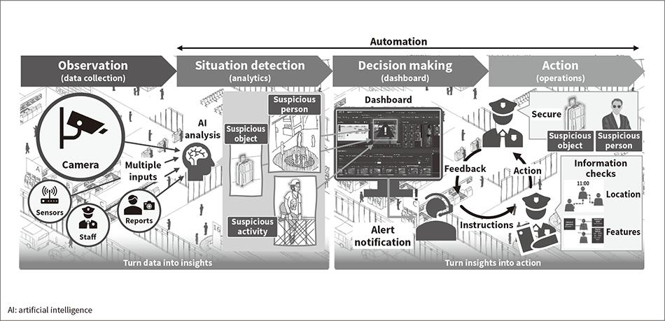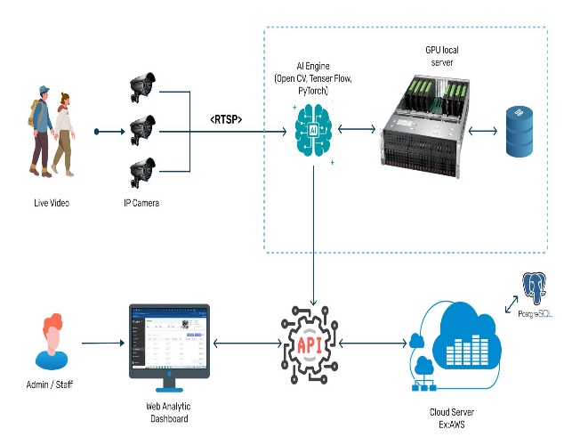
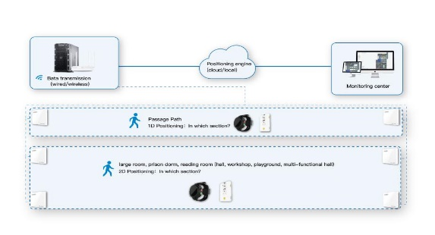
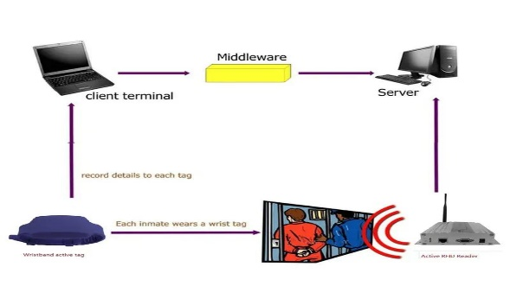

1. Data Collection Layer
This is the first stage of the system where real-time data is gathered from various devices installed across the prison.
Components involved:
- CCTV Cameras (video surveillance)
- RFID Tags (inmate and staff tracking)
- Biometric Scanners (fingerprint/face recognition)
- IoT Sensors (temperature, motion, door status)
- Wearable Devices (health and movement tracking)
Function:
These devices continuously monitor inmate movement, staff activity, environmental conditions, and access control points.
🔹 2. Data Transmission
Once data is collected, it is transmitted to the central system.
Technologies used:
- Wi-Fi / LAN / 5G networks
- Secure communication protocols
Function:
Ensures real-time and secure transfer of data from devices to servers without delay or data loss.
🔹 3. Data Processing Layer
At this stage, the system processes incoming data using advanced technologies.
Key processes:
- AI & Machine Learning algorithms
- Video analytics (face detection, motion detection)
- Pattern recognition
Function:
Analyzes large volumes of data to detect patterns, identify individuals, and understand behavior.
🔹 4. Decision Engine
This is the core intelligence of the system.
Activities performed:
- Rule-based checking (restricted areas, movement limits)
- Risk analysis
- Behavior anomaly detection
Function:
Compares real-time data with predefined security policies to determine whether an activity is normal or suspicious.
🔹 5. Alert System
If any abnormal or unauthorized activity is detected, the system immediately generates alerts.
Alert methods:
- SMS notifications
- Mobile app alerts
- Email notifications
- Alarm systems
Function:
Enables quick response by informing correctional officers and authorities in real time.

🔹 6. Data Storage
All system data is stored securely for future use.
Stored data includes:
- Inmate movement logs
- Surveillance recordings
- Incident reports
- Audit trails
Function:
Supports investigations, reporting, and compliance with legal requirements.
🔹 7. User Interface Layer
This is the final stage where users interact with the system.
Interfaces available:
- Admin dashboard
- Officer mobile application
- Control room monitoring screens
Function:
Displays real-time information, alerts, and reports, allowing authorities to monitor and control prison operations efficiently.
Overall Workflow Summary
The system starts by collecting real-time data, processes it using AI, evaluates it through decision rules, and takes action by generating alerts. At the same time, all data is stored and displayed to users for monitoring and decision-making.

7. SDLC / FRAMEWORK JUSTIFICATION
7.1 Selected Model: Agile (Scrum)
7.2 Reasons for Selection
- Flexible to changes
- Faster delivery
- Continuous improvement
- Frequent feedback

7.3 Benefits
- Improved collaboration
- Early error detection
- Better product quality

8. EXPECTED OUTCOMES
- Improved security
- Faster response time
- Reduced manual work
- Better monitoring
- Data-driven decisions

9. LIMITATIONS AND CHALLENGES
- High cost
- Data privacy concerns
- Technical complexity
- Training requirements

10. FUTURE ENHANCEMENTS
- Facial recognition
- Drone surveillance
- AI-based voice monitoring
- Blockchain security
11. USE CASE ANALYSIS
Actors:
- Admin
- Officer
- Inmate
- Visitor
Use Cases:
- Monitor Inmate Movement
- Verify Visitor Entry
- Detect Suspicious Behavior
- Generate Reports
- Send Emergency Alerts

12. DATA FLOW DESCRIPTION (DFD CONTENT)
Level 0 (Context Diagram):
- Input: Sensor data, video feeds, user input
- Process: Smart Prison System
- Output: Alerts, reports, monitoring dashboard
Level 1:
- Data Collection Module
- Processing Module
- Alert System
- Database Storage

13. DATABASE DESIGN (BASIC IDEA)
Tables:
- Inmate Table
  - ID
  - Name
  - Cell Number
  - Risk Level
- Staff Table
  - Staff ID
  - Role
  - Shift
- Visitor Table
  - Visitor ID
  - Entry Time
  - Exit Time
- Alert Table
  - Alert ID
  - Type
  - Time
  - Status

14. REAL-TIME APPLICATION SCENARIOS
Scenario 1: Unauthorized Movement
- Inmate enters restricted zone
- RFID detects location
- Alert sent immediately
Scenario 2: Violence Detection
- AI detects aggressive behavior
- System sends emergency alert
- Officers respond quickly
Scenario 3: Fire Emergency
- Sensor detects smoke
- Alarm triggered
- Evacuation process initiated

15. SECURITY MECHANISMS
Data Security
- Encryption of sensitive data
- Secure cloud storage
Access Control
- Role-based login system
- Biometric authentication
System Security
- Firewall protection
- Intrusion detection system

16. PERFORMANCE REQUIREMENTS
- System should respond within seconds
- Handle large number of users
- Continuous operation (24/7)
- Minimal downtime

17. SCALABILITY AND FLEXIBILITY
The system is designed to:
- Support multiple prison facilities
- Add new modules easily
- Upgrade technology without major changes

18. TESTING STRATEGIES
Types of Testing:
- Unit Testing
  - Test individual modules
- Integration Testing
  - Test interaction between modules
- System Testing
  - Test complete system
- User Acceptance Testing
  - Ensure system meets user needs

19. MAINTENANCE STRATEGY
- Regular system updates
- Bug fixing
- Performance monitoring
- Security patch updates

20. ETHICAL AND LEGAL CONSIDERATIONS
- Protect inmate privacy
- Avoid misuse of surveillance
- Ensure data confidentiality
- Follow government regulations

21. COMPARISON WITH TRADITIONAL SYSTEM
Feature | Traditional System | Smart System
Monitoring | Manual | Automated
Security | Low | High
Response Time | Slow | Fast
Data Handling | Paper-based | Digital

22. RISK MANAGEMENT
Possible Risks:
- System failure
- Data breach
- Network issues
Mitigation:
- Backup systems
- Data encryption
- Secure network

23. FUTURE SCOPE (ELABORATED)
- Integration with AI chatbots for reports
- Predictive crime behavior analysis
- Smart rehabilitation tracking
- Integration with national security systems

24. SAMPLE ALGORITHMIC APPROACH (FOR MARKS 💯)
Example: Unauthorized Movement Detection
- Read RFID location data
- Check allowed zones
- IF inmate in restricted zone
→ Trigger alert
- ELSE continue monitoring

25. CONCLUSION
The Intelligent Smart Prison Monitoring System represents a significant advancement in correctional facility management. By combining AI, IoT, and automation, the system transforms traditional prisons into smart environments. It not only enhances security but also improves efficiency, reduces workload, and ensures better monitoring.
The system supports proactive decision-making, enabling authorities to prevent incidents before they occur. Despite challenges such as cost and complexity, the long-term benefits outweigh the limitations.

